IOD
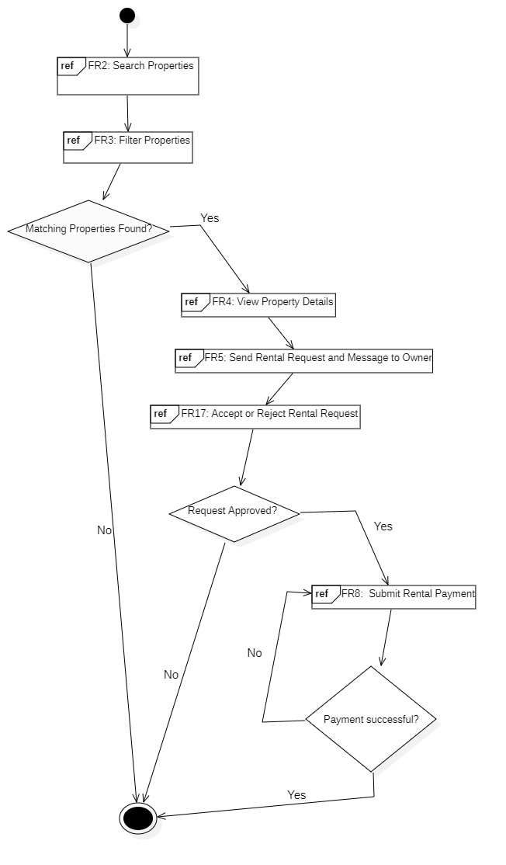
Property Booking Process
Property Listing & Managment
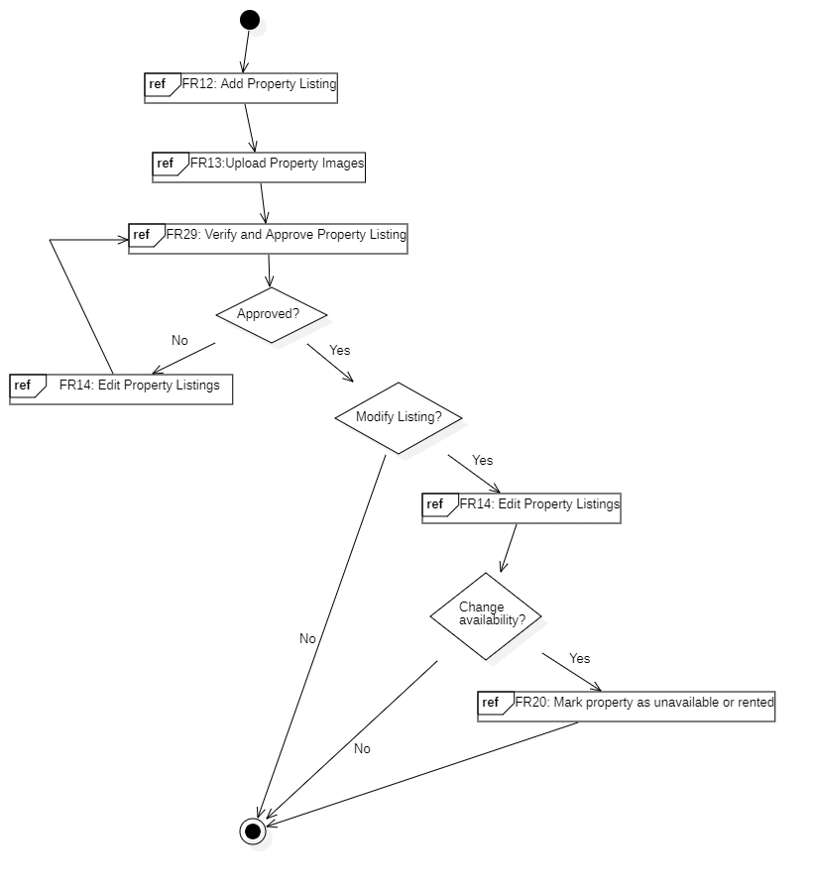

Complaint & Issue Managment

